Freedom Scale (Wellness) Technical Document
Table of Contents
1. General Purpose …………………………...………………………………………. 2
2. Data Model ………………………………………………………………………….. 2
3. Objects description …………………………………………………………………. 3
4. Classes / Pages used ………………………………………………………………… 5

1. General Purpose:
Freedom Scale (Wellness) is used to check user financial wellness status.
To check wellness status ffreedom have created set of question from that they can conclude user wellness status.

2. Data Model:
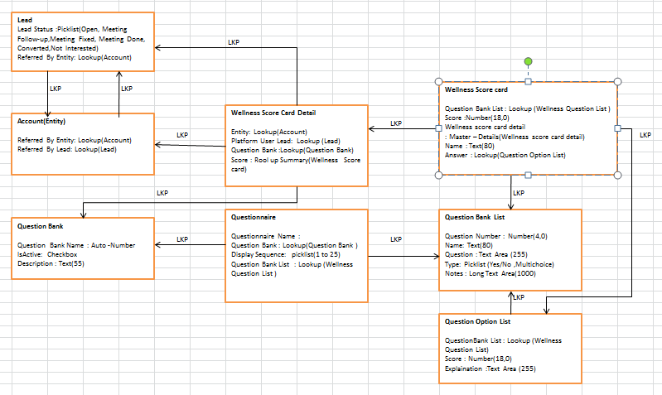

3. Objects description: There are 9 object used in developed freedom scale functionality .The object used are as follow:
Object Name | API Name | Purpose
Question Bank | Question_Bank__c | This Object used for unique name for freedom scale Questionbank List.  This is the question set Name given to set of question.
Question bank list | Question_Bank_List__c | This Object used for freedom scale question list. It contains list of question which you want to show user.
Questionnaire | Questionnaire__c | This object used for mapping QuestionBank and QustionBank list.  Relationship:  - Lookup to QuestionBank  - Lookup to QuestionbankList
Freedom scale (wellness )score card | Wellness_Score_Card__c | This object used for store total score of all qustion that user given answer.  Relationship:  - Lookup to Account  - Lookup to Lead
Wellness Option Detail | Wellness_Option_Detail__c | This object is used to store answer of all user response.  Relationship :  - Lookup to Questionbank List  - Master –Detail to Wellness Card Details
Wellness Score card details | Wellness_Card_Detail__c | This object used for Detail score of each question that user given answer.  Relationship :  - Lookup to Questionbank List  - Master–Detail to Wellness Score Card  - Lookup Question Option List
Question option list | Question_Option_List__c | This object used for option or answer for all question lists. It means 1Question have 2 or many option. So here we map answer to particular question.  Relationship:  Lookup to QuestionBankList
Account(Entity) | Account | The Wellness Score Card related list present on Account object to get wellness score of that particular Account.
Lead | Lead | The Wellness Score Card related list present on Lead object to get wellness score of that particular Lead .

4. Classes / Pages used:
There are 2 class and 2 page used for Freedom scale functionality.
Classes used: Financialwellnesscontroller
Financialwellnessreport
Page used: Financialwellness
Financialwellnessreport

Type | Name | Uses
Class | Financialwellnesscontroller | This class is used for creating question and answer for freedom scale (Wellness).
 | financialwellnessreport | This class is used for creating pdf report of user reponses to each question
Page | Financial wellness page | This page is used to show financial wellnes question and option.
 | financial wellness report | This page is used to display pdf format of user response. And For each response there is some detail text.

